**Heaven’s Light is Our Guide**

**Rajshahi University Of Engineering & Technology**



**Department of Electrical & Computer Engineering Project Report**

**Course Title** : Electronic Shop Practice

**Course** **No.** : ECE 3100

**Project Name:**

**Cloud Based Air Pollution Detector**

**Submitted By**,

Name : Promit Biswas

Roll : 1810039

Department : Electrical & Computer Engineering

**Submitted To**,

Tasnim Binte Shawkat,

Assistant Professor,

Department of Electrical & Computer Engineering,

Rajshahi University of Engineering & Technology.

**Name of the Project:**

Cloud Based Air Pollution Detector

**Project Abstraction:**

Cloud Based air pollution detector is sensor-based detector which can send data to online to predict the future occurrence by the data. Those data will be sent to online cloud to store and our future prediction method (i.e., Curve Fitting) determine those things. Our sensor focuses of the Environmental Protection Agency's Air Quality Index which consists AQI level, CO2, CO, Methene, Butane, Temperature and humidity of air. The sensor we have used in our project are relatively inexpensive and vary greatly from component to component so they need to be calibrated with known concentrations of the target gasses.

It is portable air pollution detector that helps to find out the different air substances level in any specific area and predict future situation and show on a website. It will be alarmed when it detects the excessive number of harmful gases. The amount of gas particles will be displayed in LCD display. It will transfer data to Online Cloud based Website to show data in different times to predict. This Cloud based air pollution detector can detect all those things in ppm, AQI level, CO2, CO, Methene Butane in ppm (parts per million) and temperature in Celsius and humidity in percentage form

**Components we have used:**

**Control and Power-**

* Arduino Nano
* 5V power supply
* 16x2 LCD shield
* Buzzer

**Sensors-**

* MQ-2 Gas Sensor
* MQ-5 Gas Sensor
* MQ-135 Gas Sensor
* DHT11 Temperature and Humidity Sensor

**MQ-2:**

MQ2 is one of the commonly used gas sensors in MQ sensor series. It is a Metal Oxide Semiconductor (MOS) type Gas Sensor also known as **Chemoreceptors** as the detection is based upon change of resistance of the sensing material when the Gas comes in contact with the material. Using a simple voltage divider network, concentrations of gas can be detected. MQ2 Gas sensor works on 5V DC and draws around 800mW. It can detect LPG, Smoke, Methane and Carbon Monoxide concentrations anywhere from 200 to 10000ppm.

**MQ-5:**

MQ-5 gas sensor has high sensitivity to butane, propane, methane and can detect methane and propane at the same time. It also can detect kinds of flammable gases, especially LPG (propane). It is a kind of low–cost sensor for many applications. Sensitive material of MQ-5 gas sensor is SnO2, which with lower conductivity in clean air. When the target flammable gas exists, the sensor’s conductivity gets higher along with the gas concentration rising. Users can convert the change of conductivity to correspond output signal of gas concentration through a simple circuit.

**MQ-135:**

MQ135 Gas Sensor is an air quality sensor for detecting a wide range of gases, including NH3, NOx, alcohol, benzene, smoke and CO2. Ideal for use in office or factory. MQ135 gas sensor has high sensitivity to Ammonia, Sulfide and Benzene steam, also sensitive to smoke and other harmful gases. The MQ-135 Gas sensor can detect gases like Ammonia (NH3), sulfur (S), Benzene (C6H6), CO2, and other harmful gases and smoke. Similar to other MQ series gas sensor, this sensor also has a digital and analog output pin.

**DHT sensor:**

The DHT sensors are made of two parts, a capacitive humidity sensor and a thermistor. There is also a very basic chip inside that does some analog to digital conversion and spits out a digital signal with the temperature and humidity. The digital signal is fairly easy to read using any microcontroller. DHT11 sensor provides humidity value in percentage in relative humidity (20 to 90% RH) and temperature values in degree Celsius (0 to 50 °C) DHT11 sensor uses resistive humidity measurement component, and NTC temperature measurement component.

**Circuit Diagram:**

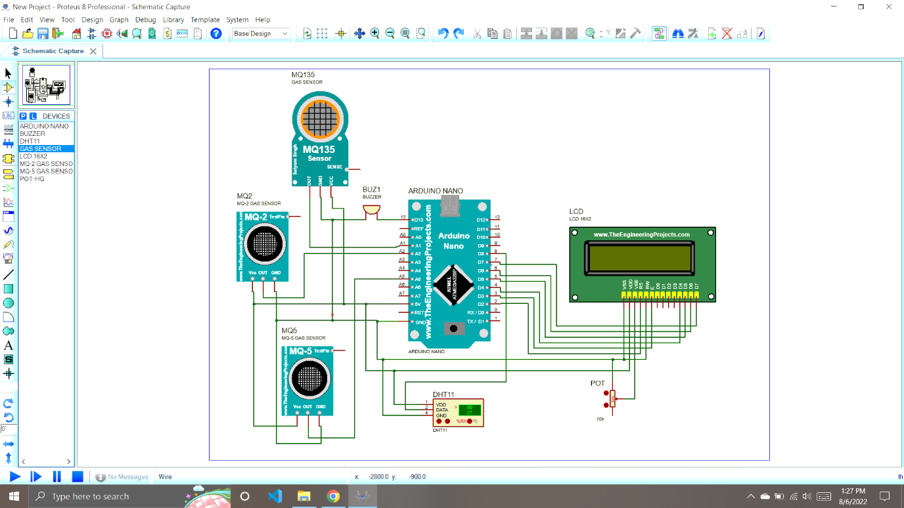

Figure: Full circuit of Cloud Base Air Pollution Detector

**Limitations:**

* It can only detect gases within a short-ranged area.
* It can’t pass data to internet.
* It only gives values to display, it can’t store in database to send online.

**Further Development:**

* It will send data to an online portal to show data
* It will predict the future occurrence
* It will be modeled in a single circuit and in a compact space to make a smaller device.
* We shall be notified if any gases become too high using our website.

**Contribution of myself:**

I figured out the circuit diagram and completed it and also contributed in coding also. I have connected the circuit as,

**MQ-2:**

In our project, I have connected the pins as VCC to the 5V pin, GND pin to GND pin of Arduino nano and connected the Aout to pin Analog 2 of Arduino nano for analog output. This pin gives the result of CO2, LPG and CO.

**MQ-5:**

In our project, I have connected the pins as VCC to the 5V pin, GND pin to GND pin of Arduino nano and connected the Aout to Analog pin 5 of Arduino nano for analog output. This analog pin gives the output of Butane.

**MQ-135:**

In our project, I have connected the pins as VCC to the 5V pin, GND pin to GND pin of Arduino nano and connected the Aout to Analog pin 1 of Arduino nano for analog output. This analog pin gives the output of AQI level which can say the air is good or not.

**DHT11:**

In our project, I have connected the pins as VCC to the 5V pin, GND pin to GND pin of Arduino nano and connected the Dout to Analog pin 8 of Arduino nano for analog output. This pin gives the digital output then it converted into analog result. It gives the humidity in percentage and temperature in Celsius.

**Display:**

Before wiring the LCD screen to Arduino board we have soldered a pin header strip to the 14 (or 16) pin count connector of the LCD screen,

To wire LCD screen to your board, I have connected the following pins:

* LCD RS pin to digital pin 2
* LCD Enable pin to digital pin 3 through 10K Potentiometer
* LCD D4 pin to digital pin 4
* LCD D5 pin to digital pin 5
* LCD D6 pin to digital pin 6
* LCD D7 pin to digital pin 7
* LCD VSS pin to GND
* LCD VCC pin to 5V

**Buzzer:**

I have connected Buzzer at digital pin 13 to Arduino nano and other pin to GND by which at high ppm this can send alert.